**Assignment 3**

**Team Members**

|  |  |  |  |
| --- | --- | --- | --- |
| **Num** | **Full Name in ARABIC** | SEC | BN |
| 1 | بيتر عاطف فتحي | 1 | 19 |
| 2 | بيشوي مراد عطية | 1 | 20 |

**Table of contents:**

1. Part One 3

1.1 Gram-Schmidt Orthogonalization 3

1.2 Signal Space Representation 4

1.3 Signal Space Representation with adding AWGN 5

1.4 Noise Effect on Signal Space 6

2. Appendix A: Codes for Part One: 7

A.1 Code for Gram-Schmidt Orthogonalization 7

A.2 Code for Signal Space representation 7

A.3 Code for plotting the bases functions 7

A.4 Code for plotting the Signal space Representations 8

A.5 Code for effect of noise on the Signal space Representations 8

**List of Figures**

Figure 1 Φ1 VS time after using the GM_Bases function 5

Figure 2 Φ2 VS time after using the GM_Bases function 5

Figure 3 Signal Space representation of signals s1,s2 6

Figure 4 Signal Space representation of signals s1,s2 with E/σ¬2 =10dB 7

Figure 5 Signal Space representation of signals s1,s2 with E/σ¬2 =0dB 7

Figure 6 Signal Space representation of signals s1,s2 with E/σ¬2 =-5dB 8

# Part One

## 1.1 Gram-Schmidt Orthogonalization

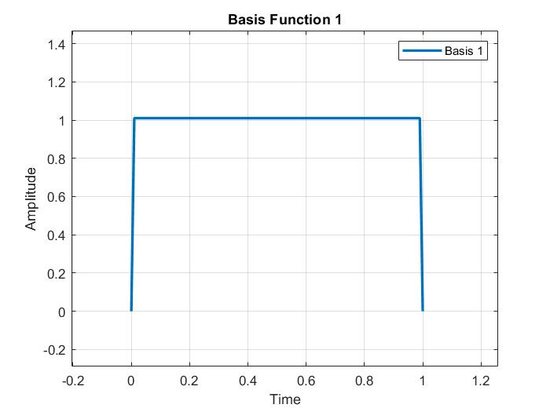

Figure Φ1 VS time after using the GM_Bases function

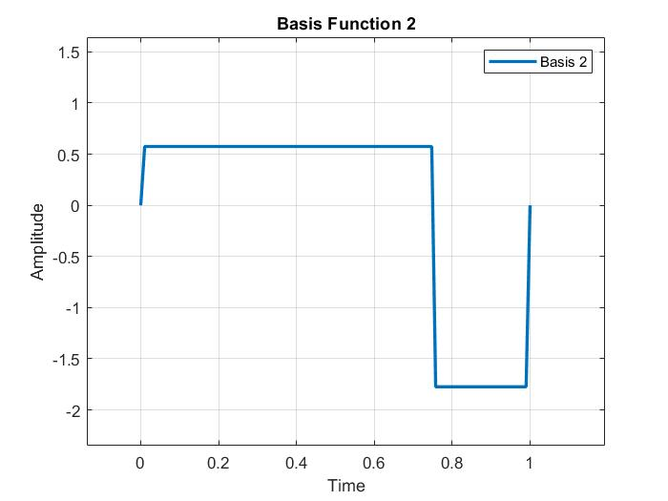

Figure Φ2 VS time after using the GM_Bases function.

**Solution verification:**

So, the bases are orthogonal.

## 1.2 Signal Space Representation

Here we represent the signals using the base functions.

Figure Signal Space representation of signals s1, s2

## 1.3 Signal Space Representation with adding AWGN

-the expected real points will be solid and the received will be hollow

**Case 1**:

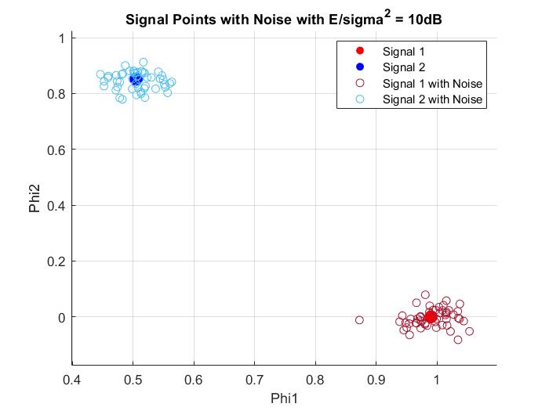

Figure Signal Space representation of signals s1, s2 with E/σ¬2 =10dB

**Case 2**:

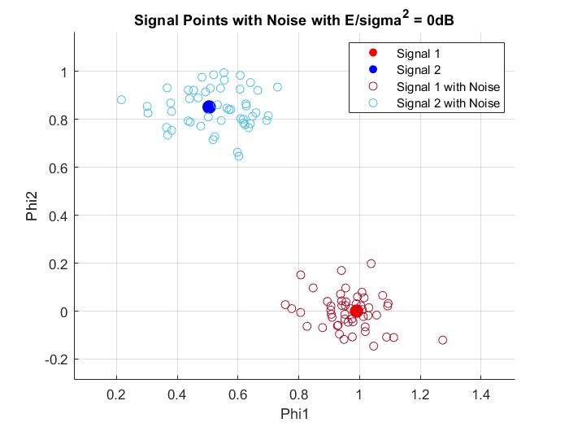

Figure Signal Space representation of signals s1,s2 with E/σ¬2 =0dB

**Case 3**:

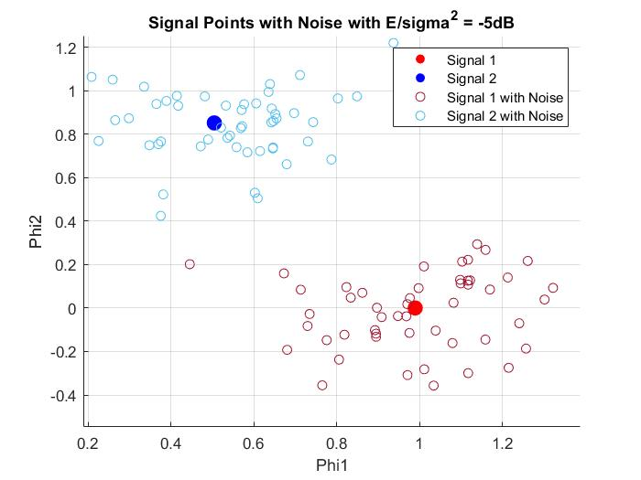

Figure Signal Space representation of signals s1, s2 with E/σ¬2 =-5dB

## 1.4 Noise Effect on Signal Space

How does the noise affect the signal space?

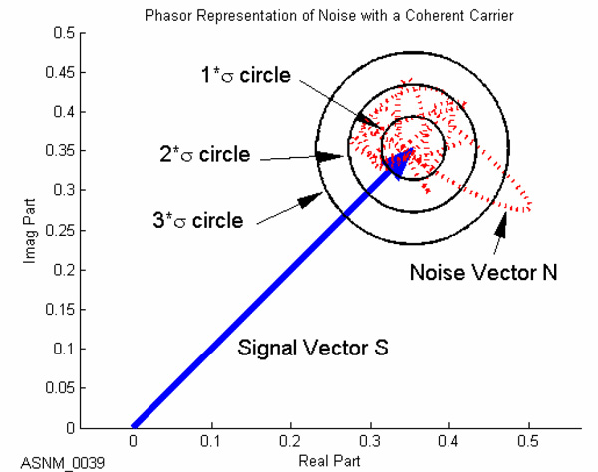Receiver will get

Then we find

The receiver will get a signal yij whose space vector near to the space vector of Sij “the space vector of the sent pulse.”

Does the noise effect increase or decrease with increasing 𝜎2?

It’s noticed that with the increase of the variance of the noise, the signal to noise ratio decreases then the probability of error increases “the uncertainty increases” as observed from the following image.

# References

1. Matlab documentations for rectangularPulse function
2. [Wikipedia](https://en.wikipedia.org/wiki/Additive_white_Gaussian_noise#Effects_in_phasor_domain)

# Appendix A: Codes for Part One:

## A.1 Code for Gram-Schmidt Orthogonalization

function [phi1, phi2] = GM_Bases(s1, s2)

    phi1 = s1 / sqrt(dot(s1, s1));

    v2 = s2 - dot(s2, phi1) * phi1;

    phi2 = v2 / sqrt(dot(v2, v2));

    phi1 = phi1 * sqrt(length(s1));

    phi2 = phi2 * sqrt(length(s2));

end

## A.2 Code for Signal Space representation

function [v1, v2] = signal_space(s, phi1, phi2)

    v1 = dot(s, phi1) / length(s);

    v2 = dot(s, phi2) / length(s);

end

## A.3 Code for plotting the bases functions

% Construct the signals

t = linspace(0, 1, 100);

s1 = rectangularPulse(0, 1, t);

s1(1) = 0; s1(end) = 0;

s2 = rectangularPulse(0, 0.75, t) - 1 * rectangularPulse(0.75, 1, t);

s2(1) = 0; s2(end) = 0;

% =================================================================

% =================================================================

% REQUIREMENTS 1:

[phi1, phi2] = GM_Bases(s1, s2);

% Plot the signals

figure('Name', 'Basis Functions', 'NumberTitle', 'off');

plot(t, phi1, 'LineWidth', 2);

legend('Basis 1');

xlabel('Time');

ylabel('Amplitude');

title('Basis Function 1');

grid on;

figure('Name', 'Basis Functions', 'NumberTitle', 'off');

plot(t, phi2, 'LineWidth', 2);

legend('Basis 2');

xlabel('Time');

ylabel('Amplitude');

title('Basis Function 2');

grid on;

## A.4 Code for plotting the Signal space Representations

[s1_v1, s1_v2] = signal_space(s1, phi1, phi2);

[s2_v1, s2_v2] = signal_space(s2, phi1, phi2);

% Plot the signal

figure('Name', 'Signal Space Representation', 'NumberTitle', 'off');

plot([0 s1_v1], [0 s1_v2], '-o', 'MarkerIndices', [2 2], 'LineWidth', 2);

hold on;

plot([0 s2_v1], [0 s2_v2], '-o', 'MarkerIndices', [2 2], 'LineWidth', 2);

legend('Signal 1', 'Signal 2');

xlabel('Phi1');

ylabel('Phi2');

title('Signal Space Representation');

grid on;

## A.5 Code for effect of noise on the Signal space Representations

function plot_signal_with_noise(testCase, s1_v1, s1_v2, s2_v1, s2_v2, s1, s2, phi1, phi2)

    % Draw the signal space representation of the signals before adding noise

    figure('Name', 'Signal Points with Noise', 'NumberTitle', 'off');

    scatter(s1_v1, s1_v2, 100, 'r', 'filled');

    hold on;

    scatter(s2_v1, s2_v2, 100, 'b', 'filled');

    % E / sigma^2 list in dB

    EoSigma = [-5, 0, 10];

    Es1 = sqrt(dot(s1, s1)) / sqrt(length(s1));

    Es2 = sqrt(dot(s2, s2)) / sqrt(length(s2));

    sigma1 = Es1 ./ db2mag(EoSigma);

    sigma2 = Es2 ./ db2mag(EoSigma);

    for i = 1 : 50

        r1 = signal_space_with_noise(s1, sigma1(testCase));

        r2 = signal_space_with_noise(s2, sigma2(testCase));

        % Calculate signal space representation of the generated samples

        [r1_v1, r1_v2] = signal_space(r1, phi1, phi2);

        [r2_v1, r2_v2] = signal_space(r2, phi1, phi2);

        % Draw the signal space representation of the signals after adding noise

        scatter(r1_v1, r1_v2, [], [0.6350 0.0780 0.1840]);

        scatter(r2_v1, r2_v2, [], [0.3010 0.7450 0.9330]);

    end

    legend("Signal 1", "Signal 2", "Signal 1 with Noise", "Signal 2 with Noise");

    xlabel('Phi1');

    ylabel('Phi2');

    title('Signal Points with Noise with E/sigma^2 = ' + string(EoSigma(testCase)) + 'dB');

    grid on;

end

% Function calls to plot the signals with noise

plot_signal_with_noise(1, s1_v1, s1_v2, s2_v1, s2_v2, s1, s2, phi1, phi2);

plot_signal_with_noise(2, s1_v1, s1_v2, s2_v1, s2_v2, s1, s2, phi1, phi2);

plot_signal_with_noise(3, s1_v1, s1_v2, s2_v1, s2_v2, s1, s2, phi1, phi2);

% =================================================================